Richard Kamens, Myoseon Jang, Sangdon Lee, and Mohammed Jaoui; Department of Environmental Sciences and Engineering, UNC-Chapel Hill, Email: kamens@unc.edu; tel: 919 966 5452, fax:

Summary

Question 6. What are the precursor compounds for secondary organic aerosols? What are the types of vegetation, vehicle exhaust, and burning that emit these precursors and under what conditions?

For the purposes of this discussion secondary organic aerosol (SOA)material will be defined as organic compounds that reside in the aerosol phase as a function of atmospheric reactions that occur in either the gas or particle phases. Monoterpenes (C₁₀H₁₆), that are emitted from vegetation, have long been implicated in secondary aerosol formation since Went published a paper on the subject in 1960. Monoterpenes represent about 10% of the natural non-methane hydrocarbon (NMHC) emitted by the vegetation to the atmosphere. Terpenes react in the atmosphere with hydroxyl radicals (OH), nitrate radicals (NO₃) and ozone (O₃). Recent measurements of individual terpene concentrations suggest ranges from 10 to 63 pptV. α-pinene tends to be the most ubiquitous terpene. Given its average ambient concentration, and aerosol potential, on a reacted mass basis, it may account for about 20-25%% of the potential secondary aerosol mass from terpenoid type compounds; d-limonene may be as high as 20% and β-pinene from 7-15%.

Susquiterpenes are a class of unsaturated C₁₅H₂₄ biogenic compounds also released from vegetation. There is a dearth of data on the emissions strength of sesquesterpenes, although it has been estimated by Helmig et al. that sesquiterpenes may contribute as much as 9% to the total biogenic emissions from plants. Other estimates are much lower. Lifetimes in the presence of a night time average background of NO₃ (5x10⁸ molecules cm⁻³), for all of the sesquiterpenes, with the exception of longifolene, are in the range of 1-5 minutes. In the presence of 30 ppb of O₃ β-caryophyllene and α-humulene have life times on the order of minutes. These compounds on a reacted mass basis have 3-5 times the aerosol potential of either α− or β−pinene. In addition to monoterpenes and sesquiterpenes, a number of oxygenates are emitted by vegetation. These include alcohols, carbonyls, acetates and organics acids. Of significance is that in many instances the oxygenate emissions may be higher, depending on the plant species, than monoterpene emissions.

Natural and anthropogenic fine aerosol emissions to the atmosphere are on the order of 200 to 300 Tg yr⁻¹. Biogenic aerosols represent ~10% of this figure. A modeling estimate by Griffin et al. for biogenic aerosols is 13 to 24 Tg yr⁻1; it is on the same order of magnitude for predictions of anthropogenic soot, and natural or anthropogenic nitrates, but much less than sea salt or natural or anthropogenic sulfate aerosols.

According to the USEPA the major atmospheric sources of aromatics in the US from 1988 to 1998 were solvent utilization and transportation sources. Volatile aromatic compounds comprise a significant part of the urban hydrocarbon mixture in the atmosphere, up to 45% in urban US and European locations. Toluene, m-and p-xylenes, benzene and 1,2,4-trimethyl benzene, o-xylene and ethylbenzene make up 60-75% of this load. In the rural setting the picture is quite different. At a rural site in Alabama in the summer of 1990, aromatics contributed ~1.7 % to the overall VOCs. Alkenes were the major category, with isoprene and α-pinene and β-pinene making up 37, 3.5, and 2% of the VOCs. Alkanes made up 9% and oxygenates 46%. In a recent study on the hydrocarbon emissions from two tunnels aromatic emissions comprised 40-48% of the total nonmethane hydrocarbon emissions for light and heavy duty vehicles. On a per mile bases heavy duty trucks emit more than twice the aromatic mass, that light duty vehicles emit, and the distribution of aromatic is different between these two classes. The six aromatic compounds mentioned above comprised ~60% of the light duty emissions, but only about 27% of the heavy duty emissions.

The chamber work of many investigators clearly demonstrate that aromatics have to potential to generate secondary aerosol material. The primary atmospheric reaction of gas phase aromatics involves the OH radical. This reaction produces a host of dicarbonyls, carboxylic acids, and hydroxy carbonyl compounds. At a TSP concentration of 100μg/m³, and using the Pankow relationship for absorptive partitioning, 0.1% of the multi carbonyl-OH compound, 0.06% of a buten-al-oic compound, and 15% of a dicarbonyl-alcohol-carboxylic acid would be in the aerosol phase. A host of new ring-opening products, which include oxo-butenoic, dioxo-pentenoic, methyl-oxo-hexendienoic, oxo-heptadienoic and trioxyohexanoic carboxylic acids, as well as similar analog aldehdyes were recently identified by Jang and Kamens, along with chemical mechanisms to explain their formation have recently been reported. Many of these products were major components in the particle phase. Very few of these products have been observed in ambient samples, although the under predicted receptor modeling of dicarboxylic acid aerosol content by Schauer el al., may be a result of these processes.

Of the major SOA products observed in the Jang and Kamens toluene experiment, the experimental partitioning coefficients between the gas and the particle phases (^{i}K_{p}) of aldehyde products were much higher and deviated more from predicted ^{i}K. This has also been observed with α-pinene systems for product aldehydes such as pinonaldehdye and pinalic acid. This is an extremely important result, because it suggests that aldehyde products can further react through heterogeneous processes and may be a very significant SOA generation mechanism for the oxidation of aromatics in the atmosphere. As product aldehydes become incorporated into larger molecules in the particle phase, more parent aldehdyes partition from the gas to the particle phase. In a very recent study is has just been reported that inert particles acidified with sulfuric acid can promote these reactions and form much higher yields of secondary products than when acid is not present. This study also shows that dialdehydes such as glyoxal, as well as hexanal and ocatanl can directly participate in secondary aerosol formation, but this process is significantly enhanced by the presence of an acid seed aerosol. The same phenomena was observed for the reaction of aldehydes and alcohols. The products of particle phase aldehyde reactions that lead to this SOA increase are probably thermally unstable and do not usually survive the workup procedure for traditional analysis techniques.

Based on the above summary of the literature the following research needs are

- Determine the importance of particle phase reactions as a source of SOA.
- Determine the importance of sesquiterpenes in SOA formation.
- Clarification of the impact of drought and relative humidity on biogenic emissions is needed so these factors can be incorporated into emission models.
- Integrated chemical mechanisms for predicting SOA from biogenics and aromatic precursors
- New analytical techniques to detect and quantify particle phase reactions. These need to be non-invasive or “chemically soft” so that complex particle phase reactions products are not decomposed.
Richard Kamens, Myoseon Jang, Sangdon Lee, Mohammed Jaoui, ,Department of Environmental Sciences and Engineering, UNC-Chapel Hill, Email: kamens@unc.edu; tel:919 966 5452, fax: 919 966 7911

Question 6. What are the precursor compounds for secondary organic aerosols? What are the types of vegetation, vehicle exhaust, and burning that emit these precursors and under what conditions? (Rich Kamens, lead)

1. Introduction:

For the purposes of this discussion secondary organic aerosol (SOA) material will be defined as organic compounds that reside in the aerosol phase as a function of atmospheric reactions that occur in either the gas or particle phases. This definition is easily applied to atmospheric reaction products of aromatics or terpenes. It would, however, exclude directly-emitted, semi-volatile compounds such as carboxylic acids, long chain alkanes, and polynuclear aromatic hydrocarbons (PAHs), that just partition from the gas to the particle phase. It would not, however, exclude nitropyrenes that may result in the particle phase as a function of particle phase relations of pyrene. It would also include other possible particle phase reactions involving aldehydes and alcohols that lead to additional gas-particle partitioning.

The relative importance of precursors to secondary aerosol formation will depend on the precursor concentration in the atmosphere and its overall aerosol potential. Aerosol potential is usually determined from laboratory/chamber studies[,,,,,, ,,,] that may qualitatively or quantitatively show aerosol products and/or demonstrate aerosol formation. Verification of secondary aerosol formation is often demonstrated by measuring the products of secondary aerosol precursors in ambient atmospheres[,,]. Historically the atmospheric reactions of monterpenes and aromatics have been associated with organic secondary aerosol formation[Error: Reference source not found,Error: Reference source not found,Error: Reference source not found,Error: Reference source not found,Error: Reference source not found,Error: Reference source not found].

2. Monoterpenes:
Monoterpenes, compounds that are emitted from vegetation, have long been implicated in secondary aerosol formation since Went published papers on the subject over 40 years^{[,14]}. The structures of some common monoterpenes are given in Figure 1. He posed the question, “what happens to 1.75x10 tons of terpene-like hydrocarbons or slightly oxygenated hydrocarbons once they are in the atmosphere?” Went suggested that one of the mechanisms by which they are removed from the atmosphere is reaction with ozone and demonstrated “blue haze” formation by adding crushed pine or fir needles to a jar with dilute ozone[]. In 1965 Rasmussen and Went[] estimated that total global biogenic vegetative organic emissions on the order of the 1940 x10¹² grams per year (Tg y⁻¹). This estimate has been revised downward somewhat in recent years. Guenther et al[] in 1995 estimated a value of 1150 Tg y⁻¹, of which 127 Tg y⁻¹ were monoterpenes. Mueller[] estimates in 1992 a terpene emission rate of 147x10¹² Tg y⁻¹. From the above figures, monoterpenes represent roughly 10-15 % of the volatile organic carbon (VOC) emitted by the vegetation to the atmosphere. Global Emission data for biogenic hydrocarbons from different vegetative sources have been developed by Guenther et al[Error: Reference source not found], are shown in Table 1. Emission rates for monoterpenes are almost the same as anthopogenic non-methane hydrocarbon emissions (142 x 10¹² grams m⁻³) as estimated by Middleton[].
Figure 1. Some commonly emitted terpenes

Some recent examples of ambient terpene concentrations are given in Table 2. Yu et a[Error: Reference source not found] reported terpene concentrations for San Bernardino National forest, CA, USA. Sampling was for an evening to the next midday. On average terpene concentrations ranged from 10 to 63 pptV. Hannele et al[] collected terpene data in an open field near a forested area in Finland. Monthly maximum values occurred during the summer months of July and August. The range of concentrations of from May through October of 1997 and 1998 are also given in Table 2.
Table 1. Global VOC Emissions Rates Estimates by Source and Class of Compounds in Tg carbon /year. Data taken from Guenther etl al, 1995[Error: Reference source not found]

Source | Isoprene | Monoterpenes | ORVOC | OVOC | Total VOC
Woods | 372 | 95 | 177 | 177 | 821
Crops | 34 | 6 | 45 | 45 | 120
Shrubs | 103 | 25 | 33 | 33 | 194
Ocean | 0 | 0 | 2.5 | 2.5 | 5
Other | 4 | 1 | 2 | 2 | 9
All | 503 | 127 | 260 | 260 | 1150
All values in table are in 10¹² grams of carbon per year
VOC = volatile organic carbon, ORVOC= other reactive VOC, OVOC= other VOC
Date in this table taken directly reference [Error: Reference source not found]

Table 2 Ambient Concentrations of selected terpenes (pptV)

 | Yu et al.[Error: Reference source not found]* | Hannel et al[Error: Reference source not found]
α-pinene | 22-119 | 36-148
β-pinene | 16-119 | 7- 28**
d-limonene | 13- 63 | 0- 21
Δ³-carene | 2- 21 | 8- 48
camphene | 2- 21 | 5- 35
sabinene |  | 0- 43
isoprene |  | 0-228

* Ambient temperature : 18-32ºC, %RH= 20-59%. **β-pinene/myrcene

Laboratory studies with terpenes have long shown the potential for secondary aerosol formation [Error: Reference source not found,Error: Reference source not found,Error: Reference source not found,Error: Reference source not found,Error: Reference source not found,]. Gas phase reactions generate a variety of oxygenated semi-volatile products. As an example the major products for the reaction of α-pinene with ozone are pinonaldehdye, pinonic acid, and pinic acid and oxygenated pinonaldehyes[Error: Reference source not found,Error: Reference source not found,Error: Reference source not found,]. A simple illustration of the formation of these compounds and others is shown in Figure 2[]. These product compounds have been observed in particles sampled (Table 3) in ambient air studies[Error: Reference source not found,Error: Reference source not found,Error: Reference source not found,]. Kavouras et al. report that ~20 to 40 of the aerosol mass over a Eucalyptus forest in Portugal was composed of pinonic and norpinonic acids.
Figure 2. Reaction products from α-pinene + ozone. (Figure taken from reference [Error: Reference source not found]

Table 3 Aerosol concentrations of selected terpenes products(ng m⁻³)

 | Yu et al.[Error: Reference source not found]* | Kavouras et al, 1998[Error: Reference source not found,]
Pinic acid | 0.5 | 82.7
pinonic acid | 0.8 | 9.1-140.6
norpinic aicd |  | 0.14-28.1
pinonaldehyde | 1.0 | 0.17-32
hydroxy-pinonaldehydes | 0.5
Oxo-liminoic acid | 0.8
nopinone |  | 0.03-13

3. Sesquiterpenes:
Susquiterpenes are a class of unsaturated C₁₅H₂₄ biogenic compounds released from vegetation. There is a dearth of data on the emissions strength of sesquesterpenes, although it has been estimated by Helmig et al. [] that sesquiterpenes may contribute as much as 9% to the total biogenic emissions from plants. Other estimates are lower[]. Some of the chemical structures for susquiterpenes for which Shu and Atkinson have determined atmospheric OH, NO₃ and O₃ reactivity data[]are illustrated in Figure 3. From their laboratory rate constants, Shu and Atkinson estimated tropospheric lifetimes (see Table 4) in the presence of an average global background concentrations of OH, NO₃ and ozone (1.6x10⁶ molecules cm⁻³ for OH, a nighttime concentration of 5x10⁸ molecules cm⁻³for NO₃ and 7x10¹¹ molecules cm⁻³ for O₃). Lifetimes in the presence of NO₃ for all of the sesquiterpenes with the exception of longifolene, are in the range

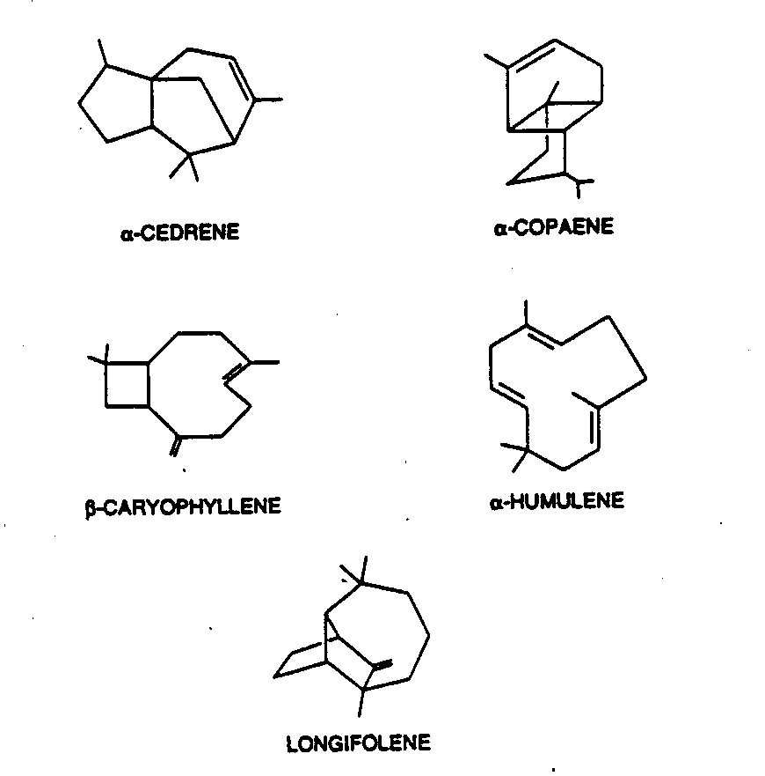
Figure 3. Some sesquiterpene structures (taken from Shu and Atkinson[Error: Reference source not found]).
of 1-5 minutes. Terpene-OH reaction lifetimes are on the order of hours to tens of hours. OH rate constants for β-caryophyllene and α-humulene are five to six times higher than for α or β-pinene (54x10⁻¹² and 79 cm³molecule⁻¹ s⁻¹ respectively), while the other are on the same order as α or β-pinene. In the presence of an average O₃ concentration of 30 ppb (7x10¹¹ molecules cm⁻³) β-caryophyllene and α-humulene have lifetimes of ~2 minutes. While the other three compounds have lifetimes in the 3 to 25 hour range. The fast reaction of β-caryophyllene and α-humulene with O₃ has implications for calculating its flux or emission rates to the atmosphere. When the flux was measured[] without an ozone scrubber d-limonene was unaffected, but β-caryophyllene was dramatically reduced due to reaction with O₃ (Figure 4). As will be illustrated in Section 5, β-caryophyllene and α-humulene, on a reacted mass basis, have much higher aerosol potentials[Error: Reference source not found] than monoterpenes. Their contribution, however, to secondary aerosols is currently unknown, but could be significant, depending on their actual emissions.

Table 4 Lifetimes of selected sesquiterpenes [Error: Reference source not found].

 | OH | NO₃ | O₃
a-Cedrene | 2.6 hours | 4 min | 14 hours
a-copaene | 1.9 hours | 2 min | 2.5 hours
β-Caryphyllene | 53 min | 2 min | 2 min
α-Humulene | 36 min | 1 min | 2 min
Longifiolene | 3.7 hours | 49 min | 23 days
* Life time =1/pseude 1st order rate constant; pseude 1st order rate constants = second order rate constant x average conc. Of OH, NO₃ or O₃.
** average OH concentration =1.6x10⁶ molecules cm⁻³; average NO₃ = 5x10⁸ molecules cm⁻³for 12 hours of night time, and ozone= 7x10¹¹ molecules cm⁻³.
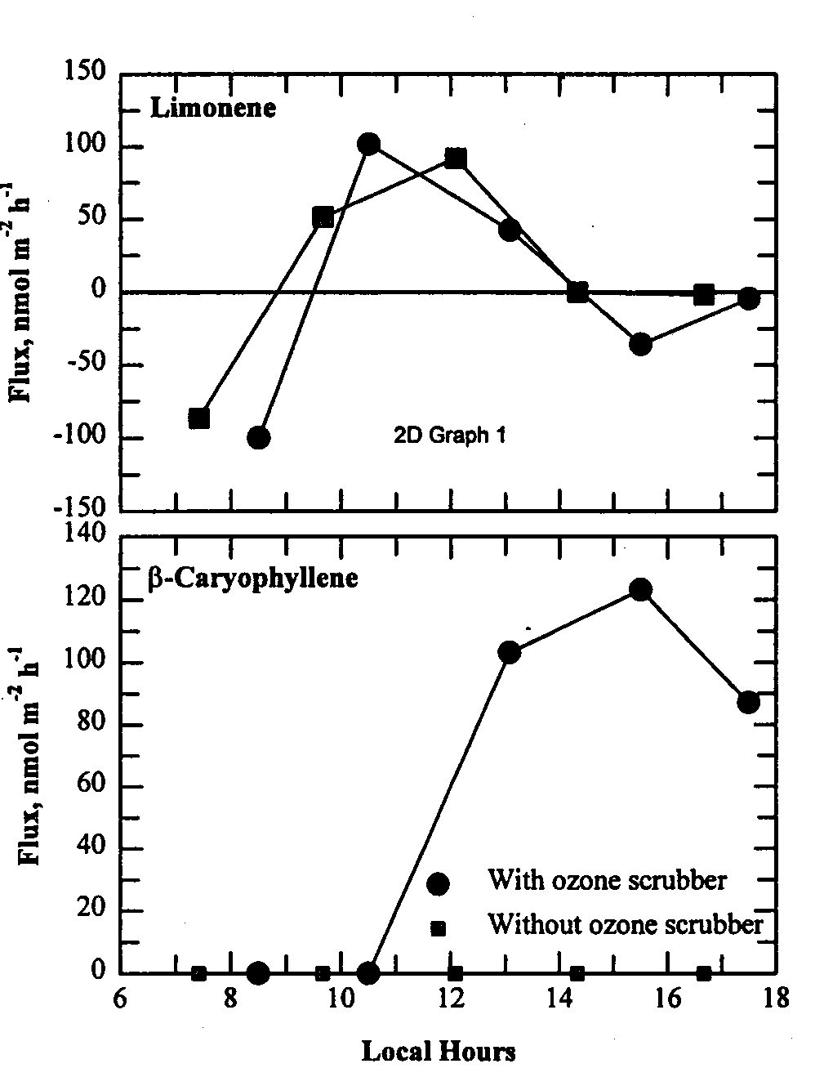
Figure 4. Sampling sesquiterpenes. Emissions per unit foliage area obtained by passing ambient air with ~50 ppb of O₃ (w/o O3 scrubber) over enclosures with orange tree branches. Figure taken directly from reference [Error: Reference source not found]

4. Other Biogenic Emissions:
Winer et al.[] using a flow through enclosure technique (with CO₂ added to 360 ppm), measured the biogenic emission from a variety of agricultural crops and natural plants/trees in central California. In addition to monoterpenes and sesquiterpenes, a number of oxygenates were measured ( Table 4 ). Of significance is that in many instances, the oxygenate emissions were higher, depending on the species, than monoterpene emissions. This has important implications, because as will be discussed below, aldehdyes and alcohols can participate in particle phase reactions that ultimately lead to the formation of more secondary aerosol mass[] . A summary of the emissions of oxygenates by various plant species is given in Kesselmeier and Staudt[]. For alcohols these include: methanol, ethanol, 2-methyl-1-propanol, 1-butanol, 2-butanol, 2-methyl-2-butranol, 2-methyl-2-butanol, 2-methyl-3-butene-2 –ol,3-methyl-1-butanol. 3-methyl-2-butene-1-0o, 3-methyl-3-buten-1-ol, 1-pentanol, 3-pentanol, 1-pentene-3-ol, 2-pentene-1-ol, 1-hexanol, 3-hexene-1-ol, 1-octanol, and l-octene-3-ol. Biogenic carbonyls include: formaldehyde, acetaldehyde, propanal, acetone, butanal, i-butanal, butenal, i-butenal, butanone-2, crotonaldehyde, pentanone-2, 2-methyl,2-2pentenal, hexanal, (E)-2-2-hexenal, (Z)-3-hexenal, octanone-3, nonal, benzaldehyde, citronellal, 6,6-dimethyl-biclyclo [3.1.1]-heptane-2carboxaldehyde, methyl-isopropyl-ketene, methyl-vinyl-ketone, and methacroline.

Table 4. Oxygenates and other compounds measured from plant
emissions in Central California.

alcohols | ketones | alkanes
p-cymen-8-ol* | 2-heptanone | n-hexane  and C10-C17
cis-3-hexen-1-ol | 2-methyl-6-methylene-1-7-octadien-3-one* | Aromatics  p-cymene
linalool | pinacarvone* | alkenes
acetates | verbenone* | 1-decene
bornylacetate | ethers | 1-dodecene
butylacetate* | 1-,8 cinole | 1-hexadecene*
cis-3-hexenylacetate | p-dimethylhydroxy benzene | p-mentha-1,2,8-triene*
aldehydes | esters | 1-pentadecene*
n-hexanal | methylsalicyclate* | 1-tetradecene
trans-2-hexenal

In addition to direct organic vegetative emissions, the surfaces of plants are covered with waxy long chain n-alkanes. These compounds have odd carbon numbers in the C₂₅ to C₃₅ range[]. Even carbon number n-alkanoic and n-alkanols are indicative of vegetative contributions to ambient aerosols, with acids being in the C₂₂-C₃₄ range, while C₁₀-C₁₈ suggest microbial sources. Although these may be considered direct atmospheric emissions, aldehydes associated with the leaf wax may be converted atmospherically to carboxylic acids[Error: Reference source not found,].
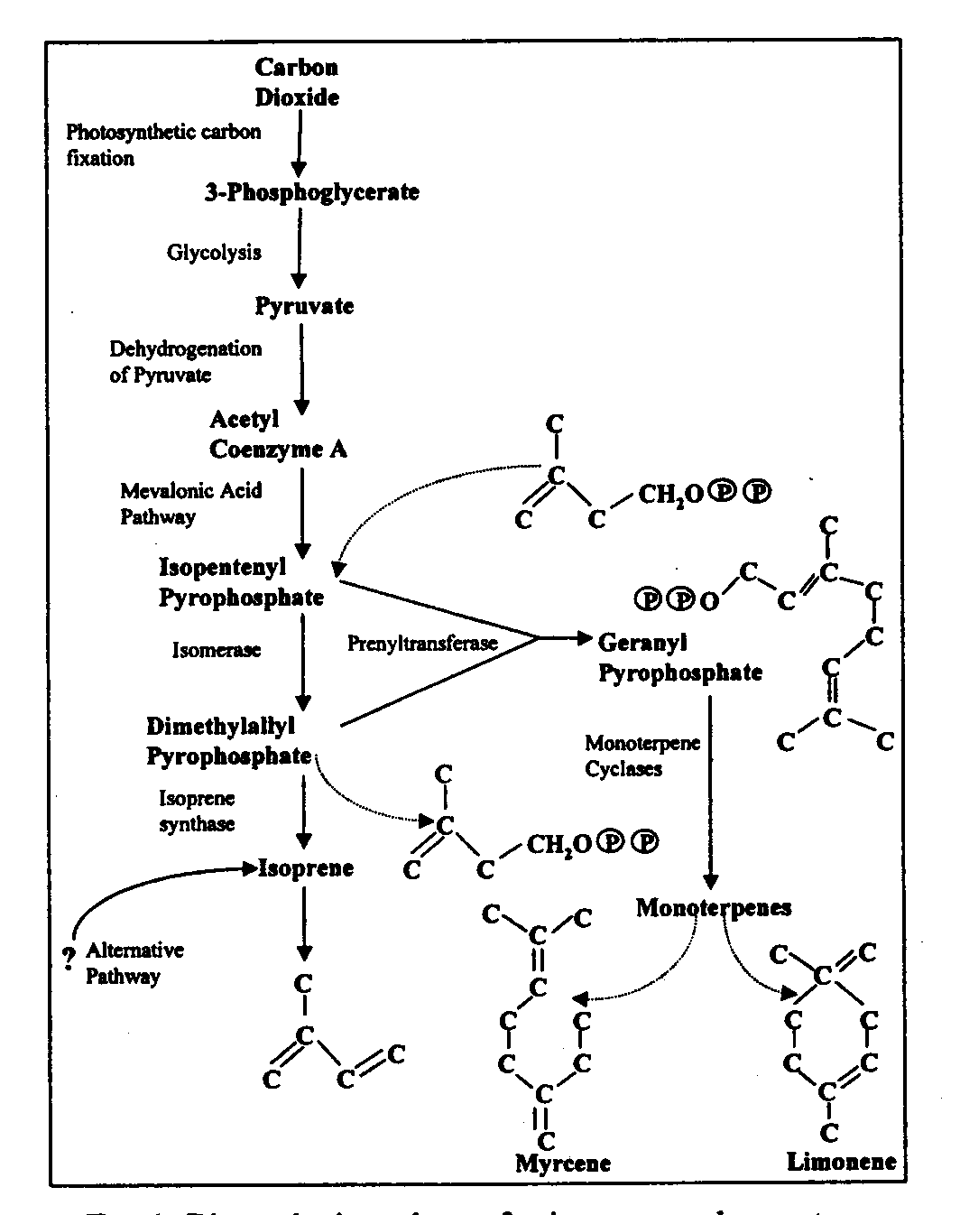

Figure 5. Biosynthesis of isoprene and monoterpenes in plants; taken directly from reference [Error: Reference source not found].

5. Factors that influence Emissions of Terpenes
Monoterpenes are produced metabolically in plant from geranyl phosphate. The synthesis of isoprene and terpenes within the plant from CO₂ is illustrated in Figure 5 as per Fuentes et al.[Error: Reference source not found]. Isoprene is produced from a light activated enzyme and the rate of this process has been correlated with isoprene emissions[]. Unlike isoprene, terpenes can be stored in plant tissue in resin ducts[,]. Thus their emissions may not immediately dependent on light. Temperature is one of the most significant factors that influences terpene emissions. Emission factors follow an exponential increase with temperature as illustrated in Figure 6a[Error: Reference source not found]. This is similar to the way vapor pressure changes with temperature. The issue of the impact on emissions of temperature vs. light is not, however, completely resolved. Kesselmeire et al[] using enclosed Mediterranean Oak (Querus ilex) experiments, showed a much closer relationship between α-pinene emissions and plant CO₂ exchange (or photosynthetic activity) than temperature (Figure 6b). Coniferous forests tend to be high terpene emitters while, by comparison temperate deciduous forest tend to emit lower levels of terpenes[Error: Reference source not found]. Compared to moderate temperature coniferous forests, tropical forest have many terpene emitting trees and plants. Tingey et al.[], described the emission rate of terpenes as a function on temperature.

E = Es exp {β (T-Ts)} eq.1

where Es is the emission rate at some standard temperature, Ts and β is the slope of the ln Es, 1/T relationship.
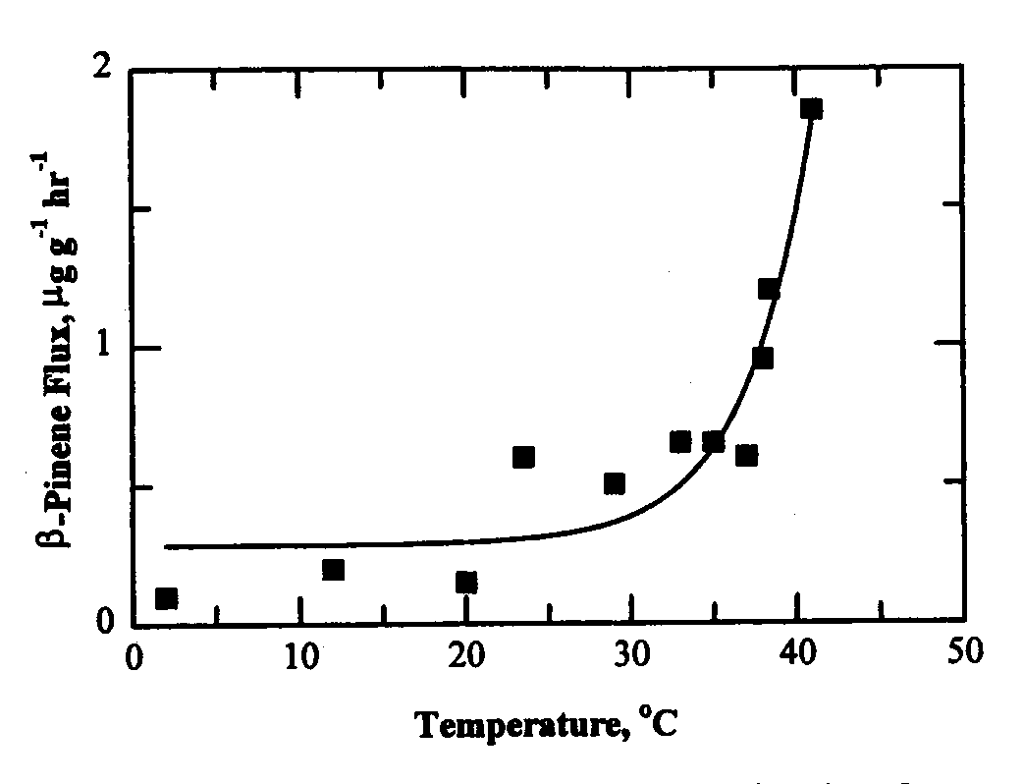
Figure 6a. β-pinene emission rates per gram of dry biomass as a function of temperature; Taken from reference [Error: Reference source not found]

Changes in relative humidity are currently not deemed to be an important factor affecting terpene emissions[]. Hansen and Seufert[] investigated terpenoid emissions from a young orange tree branch under drought stress by withholding water from the plant. The primary terpenoid emissions were β-caryophyllene and trans-β-ocimene, and decreased little (-6%) from the non-drought conditions. Others, however, have measured increases in monoterpene emissions over a ponderosa pine plantation in the Sierra Nevada mountains after rain events and under high humidity conditions[]. For Δ-3 carene, emissions the Tingey equation (eq 1) above is corrected by multiplying by a relative humidity factor, BET,
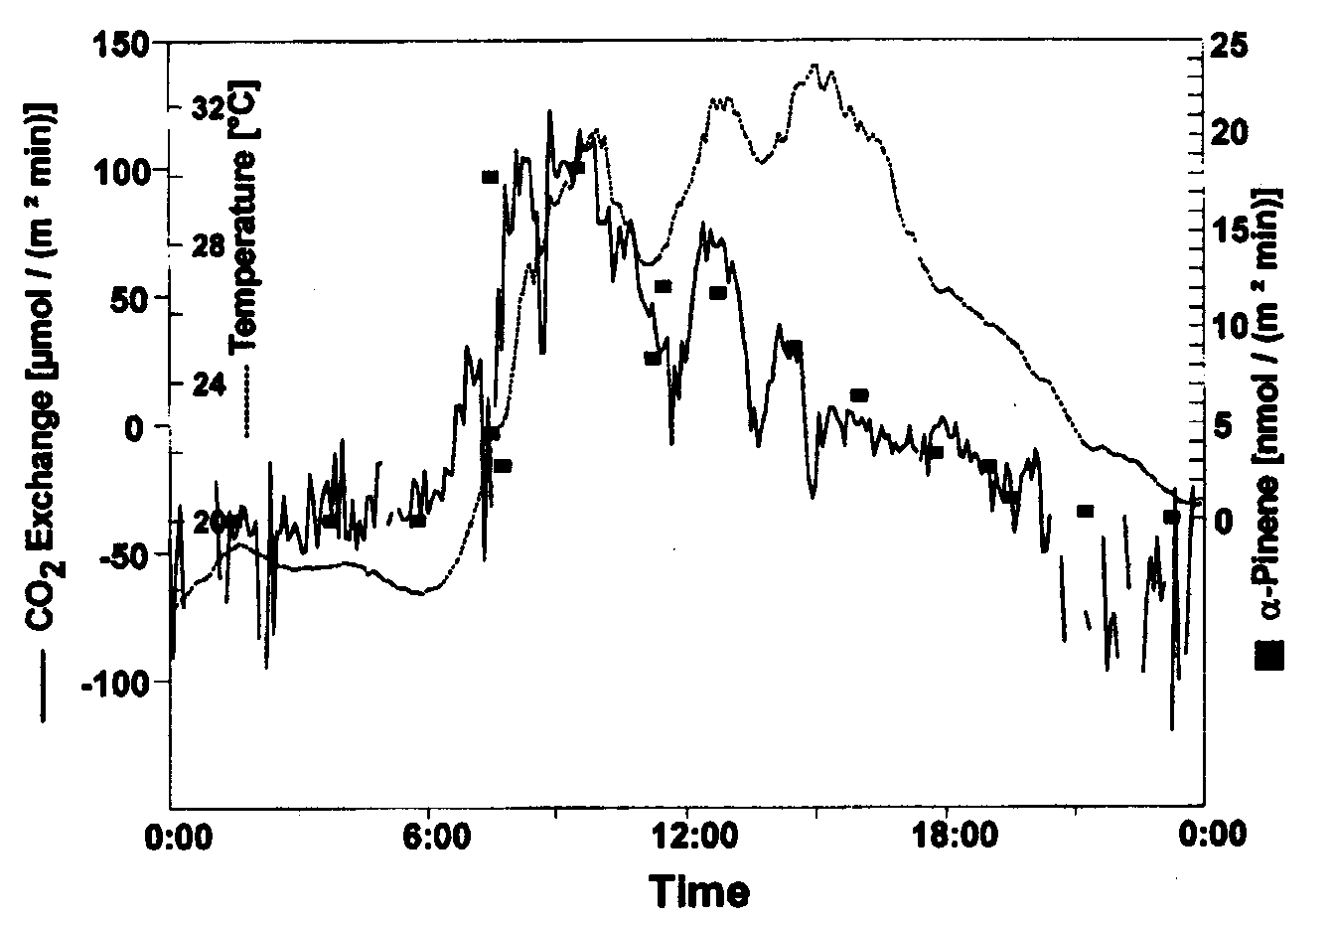
Figure 6b. α-pinene emissions of from a Mediterranean Oak branch vs. temp and CO2 exchange[Error: Reference source not found].

BET= cxRHn)/((1-cRHn)x(1+(c-1)xRHn) eq 2.
where c a constant, and RHn a normalized relative humidity = (%relative humididy-18)/82.

Emissions from drought-stressed apple leaves seem to show significant increases in hexanal, 2-hexenal, hexanol, and hexanal[]. Other factors that influence emissions have been summarized by Kesselmeier and Staudt[Error: Reference source not found] and include mechanical stress. Emissions from damaged leaves contain C₆-aldehydes and alcohols. Temporary increases in terpene emissions can result from mounting plants in chambers. Isoprene emissions seem unaffected by plant damage. Injury to the bark of pine trees increases terpene emissions. Fungal attack on lodgepole pines releases terpenes and high amounts of ethanol, thought to attract pine beetles.

6. Contribution of Emissions of Terpenes and Sesquiterpens to secondary organic aerosols:
Odum and co-workers[Error: Reference source not found,] were able to develop a gas-particle partitioning model to fit aerosol yields from reacting hydrocarbons as a function of the amount of organic aerosol, M_{o}, that forms from the atmospheric oxidation of the gas phase hydrocarbon. The yield of aerosol material, Y, the ratio of M_{o} to the amount of reacted hydrocarbon , ΔHC can be expressed as: eq. 3
M_{o} (μgm⁻³)

Figure 7. SOA yields for α-pinene as a function of Mo, taken from Odum et al. [Error: Reference source not found]. Numerically determined values for α1,α2,Mon1 and Kom2 by Odum et al were: 0.038, 0.0326,0.,and 0.004

Where the yield, Y, is function of two hypothetical product dependent gas-particle partitioning coefficients, K_{om,1} and K_{om,2}, the associated individual mass-based stoichiometric reaction coefficients, α₁, and α₂, and the absorbing organic mass concentration, M_{o} (μg m⁻³). Numerical fitting to smog chamber yield and M_{o} data for individually reacting hydrocarbons provide solutions to K_{om,1} ,K_{om,2} and α₁, and α₂. An example for α-pinene is shown in Figure 7, where each point represents as separate smog chamber experiment. Griffin et al.,[Error: Reference source not found] reported Odum fitting values (K_{om,1} ,K_{om,2} and α₁, and α₂) for a number of terpenes from O₃, NO₃ and photochemical oxidation, and was able to apportion the aerosol mass resulting from, OH , O₃ and NO₃ reaction of the starting hydrocarbons. For their chamber experiments with α-pinene, Δ³-carene, β-pinene and sabinene, ~40-70% of the aerosol mass resulted from OH ,~10-15% from O₃ and 5-20% from NO₃ oxidation.

Table 5 Photochemical aerosol fitting parameters for biogenic organics as reported by Grffin et al.[Error: Reference source not found], for us in estimating biogenically generated global aerosol mass

 | α₁ | α₂ | Kom,₁ | Kom,₂ | %Yield (Y)
Δ³-carene | 0.057 | .0476 | 0.063 | 0.0042 | 2.3-10.9
β-caryophyllene | 1.00 | N/A | 0.0416 | N/A | 17.2-63.5
α−humulene | 1.00 | N/A | 0.0501 | N/A | 20.0-66.7
limonene | 0.0239 | 0.363 | 0.055 | 0.0053 | 6.1-22.8
linalool | 0.0.073 | 0.053 | 0.049 | 0.0210 | 1.9-7.3
myrcene | 0.100 | 0.275 | 0.0513 | 0.0032 | 7.7-12.7
ocimene | 0.045 | .0149 | 0.174 | 0.0041 | 2.4-6.0
α-pinene | 0.038 | 0.326 | 0.171 | 0.0040 | 2.4-7.8
β-pinene | 0.113 | 0.239 | 0/094 | 0.0051 | 4.2-13.0
sabinene | 0.060 | 0.376 | 0.406 | 0.0038 | 4.7-10.6
α-&γ-terpinene | 0.091 | 0.367 | 0.081 | 0.0046 | 3.4-12.7
terpinene-4-ol | 0.049 | 0.063 | 0.159 | 0.0045 | 2.3-5.2
terpinoline | 0.046 | 0.034 | 0.185 | 0.0024 | 2.3-4.4

Andersson-Sköld and Simpson[] recently used the relative aerosol yields by Griffin et al[Error: Reference source not found] from different terpenes and combined these with relative emissions of different terpenes to estimate the relative aerosol potential of different terpenes. On this basis, α-pinene has the highest contribution to secondary organic aerosols (SOA.) Interestingly, while d-limonene may only represent 10% of the overall terpene emissions (depending on the vegetative species distribution), it may account for ~20% of the terpene secondary aerosol material (Figure 8). This would make d-limonene the second most important monoterpene from the perspective of aerosol formation potential. In this scheme, carophyllene ranks above β-pinene, but the β-pinene represented only 10% of the cold climate selected biogenic emissions, while other global estimates suggest a value of 20%[Error: Reference source not found].
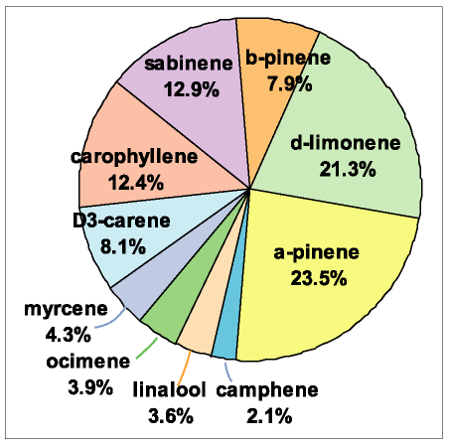

Figure 8. Relative contribution of different terpenes to SOA . Emission ratios are assumed to be α-pinene 35% by mass, β-pinene 10%, Δ³-carene 10%, d-limonene 10%, sabinene 13%, camphene 6%, myrcene 3%, ocimene 6%, carophyllene 2% and linalool 5%. Source: Andersson-Sköld and Simpson[Error: Reference source not found].

Griffin et al, [Error: Reference source not found] in a later study estimated general ambient photochemical fitting values K_{om,} , K_{om,2} and α₁, and α₂ for the biogenics as shown in Table 5. These were combined with biogenic global emission estimates (127 TgC yr⁻¹ for terpenes and 260 TgC yr⁻¹for other reactive volatile organic compounds, ORVOC by Guenther et al[Error: Reference source not found], or 147 TgC yr⁻¹ for terpenes and 94 TgC yr⁻¹for other reactive volatile organic compounds, ORVOC by Muller et al.[Error: Reference source not found]) and apportioned according to the estimated fraction of different biogenically emitted organics (Table 6) to generate concentrations in 5x5 horizontal cells in a global model. This distribution of emissions differs somewhat from Andersson-Sköld and Simpson (Figure 8) for northern climates[Error: Reference source not found]. Griffin et al., estimated that between 13 and 24 TgC yr⁻¹ of secondary aerosol material is generated each year from terpenes and other biogenics. This may be a conservative estimate, as Griffin et al. point out, because it does not take into account other existing background particle mass to which biogenic reactions products would partition. It also does not consider particle phase reactions that result in more semivolatile aldehdyes and alcohols migrating to the particle phase. In addition, the Griffin et al. fitting constants were derived at 308K and partitioning to the particle phase would be greater at a lower average global temperature. Biogenic aerosols may be compared with other natural and anthropogenic aerosol emissions as tabulated in Table 7[,]. From Table 7 is easy to see that the most significant aerosol sources on a mass basis, are re-entrained soil and mineral aerosols and sea salt aerosols. Natural and anthropogenic fine aerosol emissions to the atmosphere are on the order of 200 to 300 Tg yr⁻¹. Biogenic aerosols represent ~10% of the natural + anthropogenicly emitted fine aerosols. The Griffin et al. biogenic aerosol estimate[Error: Reference source not found] is on the same order of magnitude for predictions of anthropogenic soot, and natural or anthropogenic nitrates, but much less than sea salt or natural or anthropogenic sulfate aerosols.
Table 6 Griffin et al.[Error: Reference source not found], biogenic hydrocarbon estimates to global emissions

monoterpenes | % contribution | ORVOC | % contribution
α-pinene | 35 | terpenoid alcohols | 9
β-pinene | 23 | C2-C10  n-carbonyls | 7
limonene | 23 | Aromatics | 6
myrcene | 5 | Sesquiterpenes | 5
sabinene | 5 | Terpenoid ketones | 4
Δ³-carene | 4 | Higher olefins | 1
ocimene | 2
terpinoline | 2
α-& γ-terpinene | 1

Table 7. Best Estimates of global aerosol emissions for 1980 as as reported by Sienfeld and Pandis[Error: Reference source not found] and taken from Kiehl, and Rodhe[Error: Reference source not found].

Natural emissions | (Tg yr⁻¹) | Anthropogenic | (Tg yr⁻¹)
Soil/mineral  aerosol © | 1500 | Industrial dust  © &(f) | 100
Sea salt © | 1300 | Soot (f) | 10
Volcanic dust © | 30 | Sulfate from SO₂  (f) | 190
Biological debris © | 50 | Biomass burning  (f) | 90
Sulfates from biological gases (f) | 130 | Nitrates from NOx © | 50
Volcanic Sulfates (f) | 20 | Organics from VOCs (f) | 10
Nitrates (f) | 60
Biogenic aerosols (f) | 30
Total | 3100 | Total | 450
© means coarse aeorosl > 1 μm; (f) means < 1 μm;
** estimates are best values from a range of low and high emission estimates
*** biogenic aerosol ~2x that of Griffin et. al[Error: Reference source not found], to account for additional partitioning to other aerosol surfaces, average global temperature < 308K, and particle phase reactions

7. Aromatics:
Volatile aromatic compounds comprise a significant part of the urban hydrocarbon mixture in the atmosphere, up to 45% in urban US and European locations [,,]. Toluene, m-and p-xylenes, benzene and 1,2,4-trimethyl benzene, o-xylene and ethylbenzene make up 60-75% of this load. In the rural setting the picture is quite different. Goldan et al[], reported on volatile organic compounds (VOCs) at a rural site in Alabama in the summer of 1990. Aromatics contributed ~1.7 % to the overall VOCs. Alkenes were the major category, with isoprene and α-pinene and β-pinene making up 37, 3.5, and 2% of the VOCs. Alkanes made up 9% and oxygenates 46%.
Table 8. Average Emissions of Light and Heavy Duty Vehicles in Two Tunnels in the US in g/vehicle mile from Sagebiel et al.[Error: Reference source not found]
 |  | Fort McHenry Tunnel |  |  | Tuscarora Mountain Tunnel
 | LD |  | HD | LD |  | HD
alkanes | 231 |  | 646 | 102 |  | 295
alkenes | 112 |  | 160 | 69 |  | 114
aromatics | 271 |  | 733 | 122 |  | 277
total | 615 |  | 1539 | 293 |  | 685
aromatic fraction | 0.44 |  | 0.48 | 0.42 |  | 0.40
benzene | 23.79 |  | 19.36 | 14.75 |  | 13.73
toluene | 45.86 |  | 27.27 | 22.85 |  | 22.04
ethylbenzene | 11.30 |  | 17.26 | 4.52 |  | 3.97
m&xylene | 38.43 |  | 66.6 | 16.91 |  | 17.2
o-xylene | 14.08 |  | 22.63 | 6.46 |  | 6.85
1,2,4-trimebenzene | 24.28 |  | 45.19 | 8.51 |  | 10.62
sum | 172.5 |  | 223.4 | 79.1 |  | 80.9
% of total aromatics | 58.2 |  | 27.1 | 60.7 |  | 26.9
LD = light duty vehicles which include spark ignition and diesel automobiles, motorcycles, utility vehicles and pickup trucks; HD= busses and heavy duty trucks

Sangebiel et al[] measured the average emissions from light and heavy duty vehicles in the Fort McHenry Tunnel, a heavily used tunnel under Baltimore Harbor, and the Tuscarora Mountain Tunnel on the Pennsylivinia Turn Pike (Table 8). Aromatic emissions comprise 40-48% of the total nonmethane hydrocarbon emissions for LD and HD vehicles. On a per mile bases heavy duty trucks emit more than twice the aromatic mass that light duty vehicles emit, and the distribution of aromatic is different between these two classes. The six aromatic compounds mentioned above in the previous paragraph (also see Table 8) comprise ~60% of the light duty emissions, but only about 27% of the heavy duty emissions.

The chamber work of Odum et al[Error: Reference source not found,] , Izumi et al.[Error: Reference source not found], Holes, et al [], Kliendienst et al[], Hurley et al.[] and Jang and Kamens[Error: Reference source not found] clearly demonstrate that aromatics have the potential to generate secondary aerosol material. Illustrated in Figure 9 are the Odum et al. secondary aerosol yields from the photochemical oxidation of m-xylene in the presence of sunlight and NO_{x} along with his fit to his and the Izumi et al data.

The primary atmospheric reaction of gas phase aromatics involves the OH radical []. Reactions with O₃, NO₃ or O(³P) by comparison are negligible. OH can either abstract a benzylic hydrogen or add to the ring at a site of high electron density. In the case of toluene, OH abstraction of benzylic hydrogen initiates a reaction sequence that leads to the formation of benzaldehyde. Addition of OH to the aromatic ring of toluene can lead to cresols or ring cleavage products of which glyoxal and methyl glyoxal are typical examples[,,]. A simplified scheme for OH attack on the ortho position of toluene based on a recent review by Calvert et. al.[], is shown in Figure 10. The formation of butenedial and methylglyoxal is illustrated. Depending on the position of the oxygen bridge, glyoxal and methylbutendial can also be explained.
Figure 10. Simplified reaction scheme for OH attack on toluene.
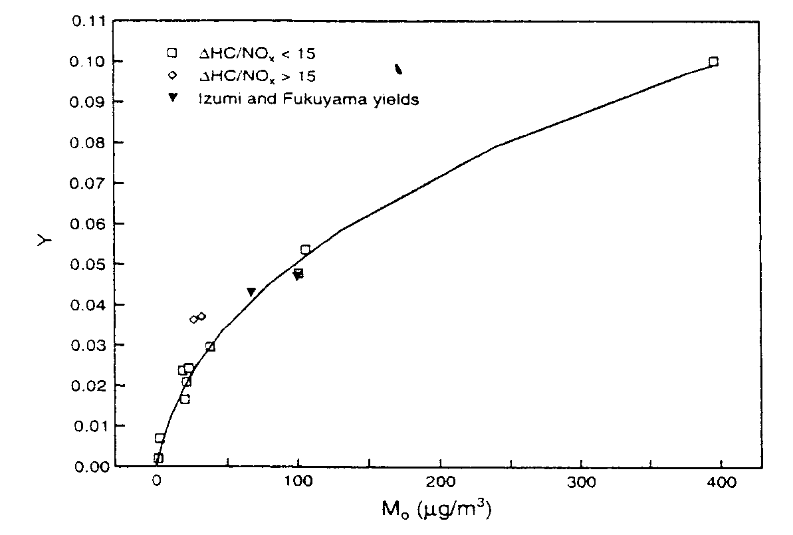
Figure 9 . Secondary Aerosol yields (y) from m-xylene chamber systems from Odum and Izumi a a function of different organic aerosols concentrations (Mo); numerically determined fitting constants α₁, and α₂, = 0.03 and0.167; constants K_{om,1} and K_{om,2}= 0.032 and 0.0019. Figure taken from Odum et al.[Error: Reference source not found];
The hydroxyl radical can further attack the double bond of butenedial, or abstract an aldehydic hydrogen. Reaction with
HO₂ will result in a buten-al-oic acid. The ring cleavage radical in the bottom of Figure 10 may also eliminate a hydrogen from the carbon-oxygen radical site and form a compound with three carbonyls and one alcohol group. The terminal aldehdye group of this compound could then undergo further oxidation and form a dicarbonyl-alcohol-carboxylic acid species.

It is possible to estimate the vapor pressure of these possible compounds using the technique of MacKay[] and the boiling point method of Joback[]. For the buten-al-oic acid and dicarbonyl-alcohol-carboxylic acid compounds these compute to be 7 x 10⁻² and 3 x 10⁻⁴ torr at 289K. An upper partitioning limit in the aerosol phase for these compounds would be if they behaved as ideal solutes in a sorbing liquid aerosol. At a TSP concentration of 100μg/m³, and using the Pankow[] relationship for absorptive partitioning, 0.1% of the multi carbonyl-OH compound, 0.06% of the buten-al-oic and 15% of the dicarbonyl-alcohol-carboxylic acid would be in the aerosol phase.

^{i}Kp = -log (7.501 RT f_{om})/ ( ^{i}Pº_{L} ^{i}γ_{om} 10⁹ MW_{om} ) eq. 4

where ^{i}Kp has units of m³/μg T is the temperature (K), f_{om} is the mass fraction of organic material in particulate matter, MW_{om} is the average molecular weight of a given liquid medium (g/mol), and ^{i}γ_{om} is the activity coefficient of a given organic compound, i, in a given organic mixture, om. R is the gas constant, 8.314 JK⁻¹mole⁻¹ and ^{i}Kp also equals Cp/(Cg xTSP), where Cp is the particle phase concentration of the semivolatile in ng/m³ and Cg is the gas phase concentrtion in ng/m³.
Figure 11. Carbonyl compounds of secondary organic products recently identified from the gas phase photooxidation of toluene/NO_{x}/2-propene system[Error: Reference source not found].

In a recent exploratory sunlight smog chamber experiment, Jang and Kamens used a combination of analytical derivatization techniques which permitted an extensive analysis of the toluene-OH-NOx sunlight system[]. A host of new ring-opening products which included oxo-butenoic, dioxo-pentenoic, methyl-oxo-hexendienoic, oxo-heptadienoic and trioxyohexanoic carboxylic acids, as well as similar analog aldehdyes (Figure 11), were identified along with chemical mechanisms to explain their formation. Many of these products were major components in the particle phase. Very few of these products have been observed in ambient samples, although the under predicted receptor modeling of dicarboxylic acid aerosol content by Schauer el al[] may be a result of these processes.

Of the major SOA products observed in the Jang and Kamens toluene experiment[Error: Reference source not found], the experimental partitioning coefficients between the gas and the particle phases (^{i}K_{p}) of
aldehyde products were much higher, and deviated more from predicted ^{i}K_{p}[Error: Reference source not found]. Kamens et al. have also observed this with α-pinene systems[Error: Reference source not found] for product aldehydes such as pinonaldehdye and pinalic acid. The deviations of toluene reaction product aldehydes from predicted partitioning estimates are illustrated in Table 9. Note that aromatic ring retaining products are not expected to undergo particle phase reactions, and measured partitioning coefficients tend to agree with theory. This is an extremely important result, because it suggests that aldehyde products can further react through heterogeneous processes, and may be a very significant SOA generation mechanism for the oxidation of aromatics in the atmosphere. As product aldehydes become incorporated into larger molecules in the particle phase, more parent aldehdyes partition from the gas to the particle phase. These observations are consistent with the work of Ziemann and co-workers[,], who have reported that alcohols and aldehydes can combine to form hemiacetals. Many of these type of compounds can have very high molecular weights and very low vapor pressures.
Table 9. Estimated and measured partitioning of selected toluene oxidation products system at 303 K.

 | Predicted  log ^{i}K_{p} | Experimental  log ^{i}K_{p}
 | -4.25 | -3.8
 | -5.64 | -5.69
 | -5.41 | -3.86
 | -6.10 | -2.66
 | -5.56 | -3.23
 | -5.38 | -3.91

Particle Phase Reactions that can lead to SOA, a new source of SOA.
Figure 12. SOA yields from heterogeneous reactions of aldehydes in the presence of an acid catalyst (A) and in the absence of an acid catalyst (N)
In another very recent study, Jang and Kamens[Error: Reference source not found] have just reported that inert particles acidified with sulfuric acid can promote particle phase reactions and form much higher yields of secondary products than when acid is not present in the seed aerosols[Error: Reference source not found]. Figure 12 shows that a dialdehyde such as glyoxal, as well as hexanal and octanal can directly participate in secondary aerosol formation, but this process is significantly enhanced by the presence of an acid seed aerosol.

The same phenomena was observed for the reaction of aldehydes and alcohols (Figure 13). The products of particle phase aldehyde reactions that lead to this SOA increase are probably thermally unstable and do not usually survive the workup procedure for traditional analysis techniques. In addition to hemiacetal/acetal formation possible reaction mechanisms for acid-catalyzed carbonyl reactions include hydration and polymerization[], as shown in Scheme 1. It is known that the equilibrium between the aldehyde and its hydrate, 1,1-dihydroxy gem-diol, is quickly established and often favors the 1,1-dihydroxy gem-diol form[]. Aldehydes may further react with hydroxy groups of the 1,1-dihydroxy gem-diol, resulting in higher molecular weight dimers, trimers and polymers[]. This multi-step reaction is often called a “zipping process” in polymer literature[Error: Reference source not found]and can be reversed by an “unzipping process”. Aldehydes react with alcohols forming hemiacetals/acetals as shown in Scheme 1. Hemiacetals, which are often too unstable to be isolated, exist only in equilibrium[,,,]. In the presence of acids, further reaction of hemiacetals leads to acetals which are relatively stable and can be isolated by neutralization[]. Hemiacetals/acetals can also be easily hydrolyzed or return to their original aldehydes and alcohols during sampling workup procedures that involve solvent extractions and derivatization procedures[,]. Compared to aldehydes, ketones convert less easily to hemiketal/ketals. However, the rate of hydrolysis reactions enormously increases with the series: formals<acetals<ketals[].
Figure 13. SOA formation in the presence and absence of an acid seed aerosol.

Scheme1. Acid catalized aldehyde reaction mechanism for hydration, polymerization, and hemiacetal/acetal formations.
This study also suggest. that acid catalyzed aldehdye particle phase polymerization is a very viable mechanism. More importantly in the context of this workshop, it suggests that particle phase reactions may be a new and significant source of semi-volatile organic aerosols. This is because large aldehydes and alcohols are not only formed via reactions in the atmosphere, but are emitted via anthropogenic and biogenic processes.

Future research areas.

- Determine the importance of particle phase reactions as a source of SOA.
- Determine the importance of sesquiterpenes in SOA formation.
- Clarification of the impact of drought and relative humidity on biogenic emissions is needed so these factors can be incorporated into emission models.
- Integrated chemical mechanisms for predicting SOA from biogenics and aromatic precursors.
- New analytical techniques to detect and quantify particle phase reactions. These need to be non-invasive or “chemically soft” so that complex particle phase reactions products are not decomposed.

9. References

Prager, M. J.; Stephens, E. R.; Scott, W. E.; Aerosol Formation for Gaseous Air Pollutants, Ind. Eng. Chem. 52,521-524, 1960
Izumi, K.; Fukuyama, T.; Photochemical Aerosol Formation From Aromatic Hydricarbons in the Presence o f NOx, Atmos. Environ. 241, 1433-1441, 1990
Hatakeyama, S.; Izumi, K.; Fukuyama, T.; Akimoto, H. ; Reactions of ozone with α-pinene and β-pinene in air: yield of gaseous and particulate products. J. Geophys.Res. 20, 13013-13024,1989.
Yu, J., Flagan R. C.; Seinfeld, J.; Identification of products Containing –COOH, -OH, -C=O in Atmospheric Oxidation of Hydrocarbons, Environ. Sci. and Technol., 32, 2357-2370, 1998.
Jang, M., and R. M. Kamens, Newly characterized products and composition of secondary aerosols from reaction of α-pinene with ozone, Atmos Environ., 33, 459-474, 1999.
Odum, J. R.; Hoffmann, T.; Bowman, F.; Collins, D.; Flagan, R. C.; Seinfeld, J. H. Gas/Particle Partitioning and Secondary Organic Aerosol Yields, Environ. Sci. Technol., 30, 2580-2585, 1996.
Glasuis, M., Lahaniati, M.; Caligirou, A.; Di Bella, D.; Jensen, N. R.; Hjorth,.J.; Duane M. J.; Kotzias, D.; Larsen B. R.; Carboxylic Acids in Secondary Aerosols from Oxidation of Cyclic Monoterpenes by Ozone, Environ. Sci. and Technol. 34, 1001-1010, 2000.
Hull, L. A. Terpene Ozonalysis Products. In Atmospheric Biogenic Hydrocarbons; Bufalini, J. J.; Arnts, R. R., Eds.; Ann Arbor Science: Ann Arbor, MI, 1981; Vol. 2, 161-186, 1981
Griffin, R. J.; Cocker, D. R., III; Flagan, R. C.; Seinfeld, J. H. Organic Aerosol Formation from the Oxidation of Biogenic Hudrocarbons. J. Geophys. Res., 104, 3555-3567. 1999
Kavouras, I. G.; Mihalopoulos, N.; Stephanou, E. G.; Formation of Atmospheric Particles from Organic acids produced by Forests. Nature, 395, 683-686. 1998.
Kavouras, I. G.; Mihalopoulos, N.; Stephanou, E. G.; Secondary Aerosol Formation vs. Primary Organic Aerosol Emission: In Situ Evidence for Chemical Couplig between Monoterpene Acid Photochemical Products and New Particle Formation over Forests. Environ. Sci. and Technol., 33, 1028-1037, 1998
Yu, J.; Griffin, R.J.; Cooker III, D.R.; Flagan, R.C.; Sienfeld, J.H.; Observations of Gaseous and Particulate Products of MonoTerpene Oxidation in Forested Atmospheres, J. Geophys. Res. Let. , 26, 1145-1148, 1999
Went, F. W., Blue Hazes in the Atmosphere, Nature, 187, 641-643, 1960.
Went, F.W, Organic Matter in the Atmosphere, and its possible Relation to Petroleum Formation,Proc National Academy of Sciences, Botany, 212-221, 1959.
Rasmussen, R.; Went, F.W.; Volatile Organic Material of Plant Origin in the Atmosphere, Procedings of the National Academy of Sciences, Botany, 215-220, 1965.
Guenther, A.; Hewitt C. N; Erickson D.; Fall R.; Geron C.; Gradel T.; Harley P.; Klenger L.; Lerdau M.; Mckay W. A.; Pierce T.; Scholes B.; Steinbrecher R.; Tallamraju R.; Taylor R. J.; Zimmerman P., A Gobal Model of Natural Volatile Organic Compound Emissions, J. Geophys. Res., 100, 8873-8892, 1995.
Muller, J.F. Geographical Distribution of Seasonal Variation of Surface Emissions and Depositon velocities of Atmospheric Trace Gases J. Geophys. Res., 97, 3787-3804 1992.
Middleton, P.; Sources of Air Pollutants, in Chemistry and Climate of the Atmosphere, ed. H.B. Singh. Van Nostrand Reinhold, New York, 88-99, 1995
Hannele, H.; Laurila, T.; Rinne, L.; Puhto, K.; The Ambinet Concentratino fo Biogenic Hydrocarbons at a Northern European, Boreal Site, Atmos. Environ, 4971-4982, 2000.
Kamens, R. M., Jeffries, H. E., Gery, M. W., Wiener, R. W., Sexton, K. G. and Howe, G. B. The impact of α-pinene on urban smog formation: an outdoor smog chamber study. Atmos. Environ. 15, 969-981. 1981.
Jaoui, M, and R. M. Kamens, Mass balance of gaseous and particulate products analysis from α-pinene/NOx/air in the presence of natural sunlight, J. Geophys Res:, 106,12541-12558, 2001.
Kamens, R. M., and Jaoui, M., Modeling aerosol formation from α-pinene + NO_{x} in the presence of natural sunlight using gas phase kinetics and gas–particle partitioning theory, Environ. Sci. Technol. 35, 1394-1405, 2001.
Stsumabayashi, H.; Kurita,H.; Yokouchi, Y.; Ueda, H.; Photochemical Formation of Particulate
Helmig D., L ; Klinger, L.F.; Greenberg, J.; Zimmermann, P.; Emissions and Identification of Individual Organic Compounds From Vegetation in Three Ecosystems in the U.S., 207 ACS Meeting Am. Chem. Soc., San Diego, California, 13-18, March 1994.
Griffin Dr. J.; Cocker, D.R.III, Sienfeld, J.H.; Estimated of Global Atmospheric Organic Aerosol from Oxidation of Biogenic Hydrocarbons, Geophys. Res. Let, 26 2721-2724, 1999;
Shu,Y.; Atkinson,R.; Atmospheric Lifetimes and Fate of a Series of Sesquiterpenes, J. Geophys. Research, 100, 7275-7281,1995.
Fuentes, J.D.; Lerdau, M.; Atkinson,R.; Baldocchi, D.; Bottenheim, J.W.; Ciccioli, R.; Lamb, B.; Geron, C. Gu, L.; Guenther, A.; Sharkey, T.D.; Stockwell, W.; Biogenic Hydrocarbons in the Atmospheric Boundary Layer: A Review, B. Amer. Met. Soc, 1537-1575, 81, 2000.
Winer, A.M.; Areay, J.; Atkinson, R.; Aschmann, S.M.; Long, W.D.; Morrison, C.L.; Olsyk, D.M.; Emission Rates of Organics From Vegetation in California’s Central Valley, Atmos. Environ., 26A, 2647-2659,1992.
Jang, M., Kamens; R.M, Atmospheric Secondary Aerosol Formation by Heterogeneous Reactions of Aldehydes in the Presence of a Sulfuric Acid Aerosol Catalyst Environ. Sci. Technol, 35, 4758-4766, 2001
Kesselmeier, J. Staudt, M.; Biologic Volatile Organic Compounds (VOC): An Overview on Emission, Physiology and Ecology, J. o f Atmospheric Chemistry, 33, 28-88, 1999.
Simoniet, B.R.T.; Cox, R.E.; Standley, L.t.; Organic Matter of the Troposphere-IV: Lipids in Harmattan Aerosols of Nigeria, Atmos. Environ. 22-1004, 1988.
Simoniet, B.R.T.; Organic Matter of the Troposphere-V: Application of Molecular Analysis to biogenic emissions into the Troposphere for Source Reconciliations, J. Atmos. Chem, 8,251-275, 1989.
Kuzuma, J.; Fall, R.; Leaf Isoprene Emissions rate is dependent on Leaf Development and the Level of Isoprene Synthase, Plant Physiol, 101, 435-440, 1993.
Monson, R.K.; Lerdau, M.T.; Sharkey, T.D.; Schimel, D.S.; Rall, R.; Biological Aspects ofConstructing Volatile Organic Compound Emission Inventories, Atmos. Environ, 29, 2989-3002, 1995.
Lerdau, M. ; Geunther, A.; Monson, R.; Plant Production and Emissions of Volatile Organic Compounds, Bioscience, 47, 16609-16615, 1997.
Kesselmeier, J.; Schafer, L.; Cicicoli, P.; Brancaleoni, E.; Cecinato, A.; Frattoni, M.; Foster, P.; Jacob,V.; Denis, J. Fugit, J. L.; Dutaur, L.; Torres, L.; Emissions of Monoterpenes and Isoprene from a Mediterranean Oak Species Quercus ilex L. Measured within the BEMA (Biogenic Emissions in the Medeterain Area) project, Atmos. Environ., 30, 1841-1850, 1996
Tingy, D.T.; Manning, M.; Grothaus, L.C.; Burnes, W.F.; Influence of Light and Temperature on Monoterpene Emissions rates from Slash Pine (Pinus Elliotti), Plant Physiology, 65, 797-801., 1980
Guenther, A.B.; Monson, R.K.; Fall, R.; Isoprene and Monoterpene Emission Variability: Observation with Eucalyptus and Emission rate Algorithum Development , J. Geophys. Res., 96, 10799-10808, 1991
Hansen, U.; Seufert,G.; Terpenoid Emissions from Citris Sinenscis (L) OSBECK Under Drought Stress, Phys. Chem Earth (B) 42, 681-687, 1999.
Shade, G.W.; Goldstein, A.H.; Lamanna, M.S.; Are Monoterpene Emissions Influenced by Humidity?, Geophys. Res. Let., 26, 2187-2190, 1999
Ebel, R.C.; Mattheis, J.P.; Buchanan, d.A.; Drought Stress of Apple Tree Alter Leaf Emissions of Volatile Compounds, Physiologia Plantarum, 95, 709-713, 1995.
Odum, J.R., P.W. Jungkamp, R.J. Griffin, H.J.L. Forstner, R.C. Flagan, and J.H. Seinfeld, Aromatics, refomulated gasoline, and atmospheric organic aerosol formation, Environ. Sci. Technol., 31, 1890-1897, 1997
Andersson-Sköld Y. and Simpson D., Secondary Organic Aerosol Formation in Northern Europe: a Model Study, J. Geophys. Res., 106, 7357-7374, 2001.
Seinfeld, J.H., and S.N. Pandis Atmospheric Chemistry and Physics: From Air Pollution to Climate Change, 1-1326 pp., John Wiley, New York, 1998.
Kiehl, J.T; Rodhe, H.; Modeling Geographical and Seasonal Forcing Due to Aerosols in Aerosol Forcing of Climate, edited by R.J. Charlston and J. Heintzenberg, Wiely, New York, 281-295, 1995
Kurtenbach, R.; K.J. Brockmann, J. ; J. Lorzer; A Niedojadlo; K. H. Becker (1998) |VOV-Measurements in Urban Air of the City of Wuppertal, in TFS-LT3 annual Report (German), K.H. Becker editor.
Fujita, E.M; Z. Lu; L. Sheetz; G. Harshfeld; B. Zilinska Determination of Mobile Source Emissions Fraction Using Ambient Field Measurements, Report to the Coordinating Research Council (CRC), 215 Perimeter Center Parkway, Atlanta, GA, 1997.
Ciccioli, R.; E. Brancaleoni; M. Frattoni The Reactive Hydrocarbons in the Atmosphere at Urban and Regional Scales, in Reactive Hydrocarbons in the Atmosphere, C.N. Hewitt(editor) Academic Press, San Diego,1999.
Goldan, P.D., Kuster, W.C. ; Fehsenfeld, F.C.; Montzka, S.A.; Hydrocarbon Measurements in the Southeast United States: the Rural Oxidants in the Southern Environment (ROSE) Program 1990, J. Geophys. Res., 100, 259454-25963,1995.
Sagebiel, J.C.; ielinska, R.; Rierson, W.P.;Gertler, A.W.: Real-World Emissions and Calculated Reactiviteis of Organic Species from Motor Vehicles, Atmos. Environ, 30, 2287-2296, 1996.
Odum, J.R., Jungkamp, P.W.; Griffin, R.J.; Forstner, H.J.L.; Flagan, R.C.; Seinfeld, J.H.; Aromatics, refomulated gasoline, and atmospheric organic aerosol formation, Environ. Sci. Technol., 31, 1890-1897, 1997.
Holes, A.; Esebi, A.; Grosgean, D.; Allen,D.; FTIR Analysis of Aerosol Formed in thePpresence of the Photooxidation of 1,2,4-Trimethylbenene, Aero. Sci. Technol. 26,516-526.
Klindienst, T.E; Smith, D.F.; Li W.; Edney, E.O.; Driscoll, D.J.;.Speer, R.E;.Weathers, W.S; Secondary Organic Aerosol Formation From the Oxidation of Aromatic Hydrocarbons in the Presence of Dry Submicron Ammonium Sulfate Aerosol Atmos. Environ. 33,3669-3681, 1999.
Hurley, M.D.; Sololov,O.; Wallingoton, T.; Tawekawa, H.; Karasawa, M.; Klotz, B; Barnes, I., Becker, K.H.; Organic Aerosol Formation during the Atmospheric Degradation of Toluene, Environ. Sci.. Technol. 35, 1358-1366
Atkinson, R., Gas-phase Tropospheric Chemistry of Organic Compounds, J. Phys. Chem. Ref. Data, Monograph No. 2, , 1-216,. 1994
Gery, M.W., D.L. Fox, H.E. Jeffries, L. Stockburger, W.S. Weathers, A continuous stirred tank reactor investigation of the gas-phase reaction of hydroxyl radicals and toluene, Int. J. Chem. Kinet., 17, 931-955, 1985
Shepson, P.B., E.O. Edney, and E.W. Corse, Ring fragmentation reactions in the photoxidations of toluene and o-xylene, J. Phys. Chem., 88, 4122-4126, 1984.
Smith, D.F., C.D. McIver, and T.E. Kleindienst, 1998 Primary product distribution from the reaction of hydroxyl radicals with toluene at ppb NOx mixing ratios, J. Atm. Chem., 30, 209-228.
Calvert, J.; R.Atkinson, K.H. Becker; R.M.Kamens, J. Seinfeld, T.Wallington, G. Yarwood , Mechanisms of Atmospheric Oxidation of Aromatic Hydrocarbons, Oxford Press, expected publication, Feb., 2002.
Mackay, D., A. Bobra, D.W. Chan, and W.Y. Shiu, Vapor pressure correction for low-volatility environmental chemicals, Environ. Sci.. Technol. 16, 16645-16649, 1982
Joback, K. G.; Reid, R. C., Chem. Eng. Commun. 57, 233, 1987.
Pankow, J. F. An absorption model of gas/particle partitioning of organic compounds in the atmosphere Atmos. Environ. 28, 185-188, 1994.
Jang, M.; Kamens, R.M.; Characterization of Secondary Aerosol from the Photooxidation of Toluene in the Presence of NO_{x} and 1-Propene, Environ. Sci. Technol,., 35, 3625-3639, 2001.
Schauer, J.J.;Rogge, W.F.; Hildemann. L.>M.; Mazurek, M.; Cass, G.R.: Source Apportionment of Airborn Particulate Matter Using organic Compounds as Tracers, Atmos. Environ., 30, 3837-3855, 1996.
Tobias, H. J.; Ziemann, P. J. Anal. Chem. 1999, 71, 3428-3435.
Tobias, H. J.; Ziemann, P. J. Environ. Sci. Technol. 2000, 34, 2105-2115.
Aldehyde and Ketones in Comprehensive Organic Chemistry: The synthesis and reactions of organic compounds, edited by Barton, D. and Ollis, W. D., Pergamond Press, New York, 960-1013, 1979.
Aldehyde and Ketones in Comprehensive Organic Chemistry: The synthesis and reactions of organic compounds, edited by Barton, D. and Ollis, W. D., Pergamond Press, New York, 960-1013, 1979.
Walker, F., Formaldehyde, 3rd ed., Reinhold Publishing, New York, 140-205, 1964
Guthrie, J. P. Can. J. Chem., 1975, 53, 898-906.
Bell, J. M.; Kubler, D. G.; Sartwell, P.; Zepp, R. G. J. Org. Chem., 1965, 30, 4284-4290.
Chastrette, F.; Chastrette, M.;Bracoud, C. Bulletin de Societe Chmique de France, 1986, 5, 822-836.
Berger, P. A.; Garbow, J. R.; DasGupta, A. M.; Remsen, E. E. Macromolecules, 1997, 30, 5178-5180.
Deyrup, A. J. J. Am. Chem. Soc., 1934, 56, 442-444.
Cordes, E. H.; Bull, H. G. Chemical Reviews, 1974, 74, 581-603.
Cordes, E. H.; Bull, H. G. Chemical Reviews, 1974, 74, 581-603.
Carey, F. A. and Sundberg, R. J., Advanced organic chemistry: part A Structure and Mechanism, Plenum Press, 1984, New York.

