EXTENDED ABSTRACT -- OC/EC Workshop, Durango, CO, March 3-5, 2003

How Does The Thermal-Optical Transmission Method Behave Optically?
A Focus On The Apparent Specific Absorption Cross Section

J.M. Conny, Surface and Microanalysis Science Division, National Institute of Standards and Technology, 100 Bureau Drive Stop 8371, Gaithersburg, MD 20899 (joseph.conny@nist.gov)

Thermal-optical analysis (TOA) for measuring elemental carbon (EC) in particulate matter (PM) relies on changes in the optical behavior of PM carbon during thermal desorption to indicate when organic carbon (OC) mass analytically ‘separates’ from EC mass. An emphasis on TOA’s optical behavior during thermal desorption presents it as a method for measuring black carbon (BC), and thus allows for a definitional link between EC and BC. With this link in mind, the major advantage of TOA for measuring EC over purely optical methods is that no prior knowledge of PM optical absorptivity is required.

In order to view thermal-optical transmission (TOT) as an accurate method for measuring BC (hence, EC), there are three assumptions of the constancy of absorptivity during analysis:
- Absorptivity of carbonaceous PM remains constant prior to OC pyrolysis, i.e., no substantive change to the particle refractive index occurs that would affect absorptivity.
- Pyrolyzed OC absorbs at the analytical wavelength (hence, chars), and absorptivity remains constant after its formation within a high-temperature step in the non-oxidizing (He) phase.
- Pyrolyzed OC has the same absorptivity as BC that is native to sample.

These assumptions were tested by determining the variation in TOT absorptivity during both the He phase and the subsequent oxidizing (O₂-He) phase for three types of samples: NIST SRM 1649a (urban dust) fine fraction, fine indoor air particles, and smoldering forest-fire emissions.

Absorptivity was calculated as the apparent specific absorption cross section following the approach of Petzold et al. [1]. $\text{ATN}(T)=−\text{100}\text{ln}\left(\frac{I(T)}{I_{0}}\right)$Analogous to absorbance at the analytical wavelength (670 nm), the temperature-dependent attenuation was calculated as

(1)

I(T) is the temperature-dependent laser response during the course of analysis, and I₀ is the laser response following the desorption of carbon, i.e., at the end of the TOT run, and corrected to the initial operating temperature (50 ºC).

ATN(T) can be described as the sum of two components: attenuation due to absorbance and attenuation due to scattering. ATN(T) can also be described as the sum of the temperature-dependent attenuation due to the carbonaceous material (ATN_{C}(T)) and the temperature-dependent attenuation due to non-carbonaceous material (ATN_{non-C}(T)):

(2)$\text{ATN}(T)={\text{ATN}}_{C}(T)+{\text{ATN}}_{\text{non}−C}(T)$

It is important to note that I₀ (eq. 1) accounts for the laser response from non-carbonacous material at 50 ºC. Therefore, neither ATN in eq. 1 nor ATN_{non-C} in eq. 2 includes the attenuation due to the non-carbonacous component at 50 ºC.

Scattering is likely the dominant contributor to ATN_{non-C} at elevated temperatures.
Absorbance and scattering both contribute to ATN_{C}. However, in this case absorbance is likely the major contributor. Therefore, ATN_{C}(T) is equal to the product of the specific carbon mass loading (S_{C}, μg cm⁻²) and the apparent specific absorption cross section (σ_{C}, m² g⁻¹):
${\text{ATN}}_{C}(T)=σ_{C}(T)S_{C}$

(3)

The figure below shows ATN(T) and σ_{C} for the lab air sample using the following desorption protocol: He step 1, 250 ºC for 120 s; He step 2, 450 ºC for 168 s; He step 3, 650 ºC for 222 s; He step 4, 850 ºC for 270 s; O₂-He step 1, 550 ºC for 60 s, O₂-He step 2, 700 ºC for 60 s; O₂-He step 3, 850 ºC for 60 s; O₂-He step 4, 900 ºC for 120 s.
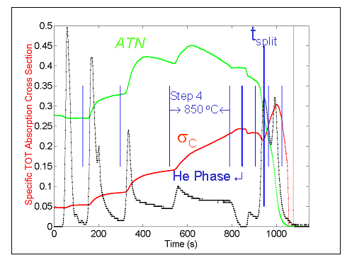

For lab air particles (as well as the other two samples) the apparent specific absorption cross section is obviously not constant throughout TOT. From the figure, assumptions 2 and 3 in particular, are violated. For example, σ_{C} does not remain constant after the formation of char during step 4 in He (assumption 2). In addition, σ_{C} values at the end of the He phase and at the split point are not equivalent (assumption 3). However, if step 4 in He is shortened from 270 s to 150 s, the split point shifts toward the right to where σ_{C} is close to its value at the end of the He phase, thus satisfying assumption 3. These results suggest that analysis of TOT absorptivity in this manner along with response surface methods [2] may lead to sample-specific TOT protocols that are optimized for accuracy in measuring EC (as BC).

[1] Petzold, A., C. Kopp, and R. Niessner, Atmos. Envir., 31, 661-672 (1997).
[2] Conny, J.M., D.B. Klinedinst, S.A. Wight, J.L. Paulsen, Aerosol. Sci. Technol. (submitted).

