A Response Surface Approach to Optimizing Thermal-Optical Methods [1]

J.M. Conny, D.B. Klinedinst, S.A. Wight, and J.L. Paulsen, Surface and Microanalysis Science Division, National Institute of Standards and Technology, 100 Bureau Drive Stop 8371, Gaithersburg, MD 20899 (joseph.conny@nist.gov)

If we define EC as light-absorbing combustion-generated carbon (i.e., BC), the benefit of thermal-optical analysis lies in the fact that EC can be measured ‘optically’ without prior knowledge of the aerosol’s absorptivity. We employed response surface methods to improve understanding of key operational variables in thermal-optical transmission (TOT) and to optimize TOT for accuracy. Surface models of three TOT responses were determined: EC/TC, maximum laser attenuation in the He phase (L_{max}), and laser attenuation at the end of the He phase (L_{He4}). L_{max} and L_{He4} were calculated as the laser responses at their respective points in the analysis relative to the initial laser response for the sample. A two-level central-composite factorial design consisting of four factors considered the temperatures and durations of the four desorption steps in TOT’s inert (He) phase and the initial step in TOT’s oxidizing (O₂-He) phase.

Response surface models [2] were full second-order polynomials with 15 terms as shown below:
Main effects
Self-interactions
Between-factor interactions
$\begin{aligned}y=b_{0}+b_{1}x_{1}+b_{2}x_{2}+b_{3}x_{3}+b_{4}x_{4}+\text{.}\text{.}\text{.} \\ b_{5}x_{1}^{2}+b_{6}x_{2}^{2}+b_{7}x_{3}^{2}+b_{8}x_{4}^{2}+\text{.}\text{.}\text{.} \\ b_{9}x_{1}x_{2}+b_{\text{10}}x_{1}x_{3}+b_{\text{11}}x_{1}x_{4}+b_{\text{12}}x_{2}x_{3}+b_{\text{13}}x_{2}x_{4}+b_{\text{14}}x_{3}x_{4}\end{aligned}$

Figure 1 below shows response surfaces of three sample types: lab air particles, NIST SRM 1649a (urban dust) fine particles (now SRM 2784), and smoldering forest fire emissions. The axes correspond to the most important factors from the experimental design: 1) temperature of step 4 in He (i.e., highest temperature in He) and 2) the duration of step 4 in He. For the three samples, EC/TC decreases with step-4 temperature in approximately 1st-order manner. EC/TC also decreases with step-4 duration for the lab air particles and urban dust, particularly at higher step-4 temperatures. Analyses of variance on lab air particle data indicated that both the temperature and duration factors were significant at the 5 % significance level [1].

Optimization was based on two hypotheses: 1) non-absorbing organic carbon (OC) that does not volatilize or pyrolyze (‘char’) in He is measured as EC during the O₂-He phase (hence, a positive bias), and 2) if loss of pyrolysis OC occurs in the He phase and the laser response does not adjust accordingly, an unaccountable loss of native EC may also occur (hence, a negative bias). To address the positive bias,

the L_{max} surface was used to optimize the production of pyrolized OC in the He phase. The presence of unpyrolyzed OC at lower He step-4 temperatures (e.g., 550 ºC and 700 ºC) was supported by scanning electron micrographs of filters showing remaining particles >2 μm that likely were charred remains of non-agglomerated OC-rich particles [1].

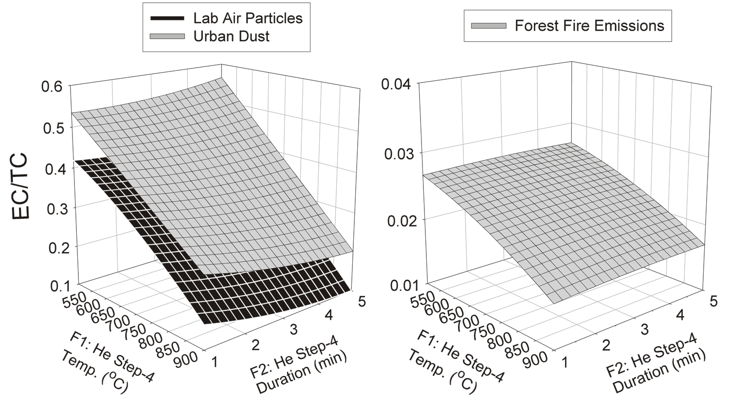
Figure 1

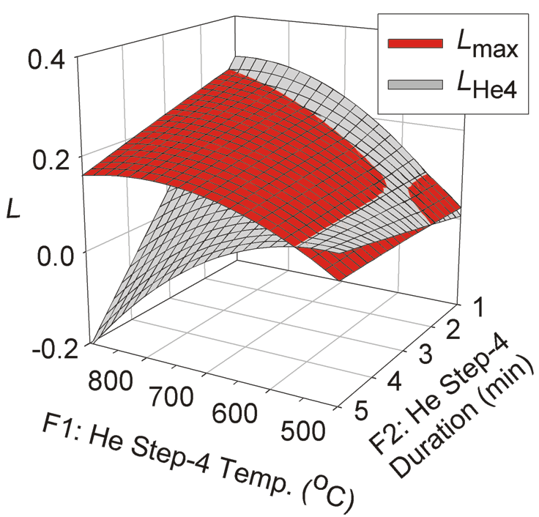
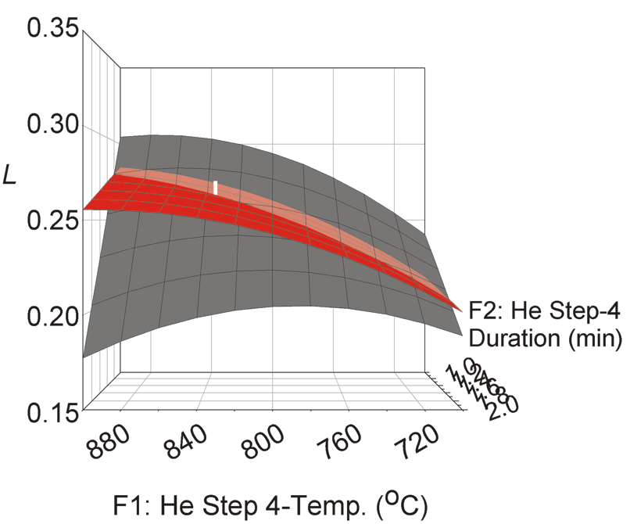
Figure 2
(a)
(b)

To address the negative bias, the L_{He4} surface was used to minimize the loss of char in He and an unaccountable loss of native EC there. Figure 2 shows both L surfaces for the urban dust. The laser response at the end of the He phase (L_{He4}) diverges sharply from the response at maximum attenuation (L_{max}) when step 4 is lengthy and its temperature is high. This divergence correlates with the decrease in EC/TC in Fig. 1 at these conditions, indicating that native EC loss is minimized when duration is shortened. The intersection between the L_{max} and L_{He4} surfaces reveals conditions that minimize potential biases, leading to an optimized desorption protocol. Fig. 2(b) is the distal corner of (a). The vertical white bar indicates standard uncertainty.

Based on an analysis of samples from this study, generalized optimal conditions for (TOT) are: step 1 in He, 190 ºC for 60 s; step 2 in He, 365 ºC for 60 s; step 3 in He, 610 ºC for 60 s; step 4 in He, 835 ºC for 72 s. For steps 1-4 in O₂-He, the conditions are 550 ºC for 180 s, 700 ºC for 60 s, 850 ºC for 60 s, and 900 ºC for 90 s to 120 s. Factorial designs and response surface methods used in this work provide powerful chemometric tools for optimizing TOT. These methods should be further exploited to optimize thermal desorption protocols that adjust for varying source-type predominance (e.g., woodburning emissions, diesel exhaust) and carbon loading.

[1] Conny, J.M., D.B. Klinedinst, S.A. Wight, J.L. Paulsen, Aerosol. Sci. Technol. (submitted).
[2] Massart, D.L. et al., Chemometrics: A Textbook, Elsevier: Amsterdam, pp. 283-286, 1988.

